Title of Abstract for 15th ISHPMIE
First Author ^{a,b}, Second Author ^{b} & Third Author ª
ª First affiliation (organization, city, country)
^{b} Second affiliation (organization, city, country)
E-mail: corresponding@author.com
Please prepare your one-page abstract for 14th International Symposium on Hazards, Prevention, and Mitigation of Industrial Explosions (14th ISHPMIE) according to this template.
A concise and factual abstract is required. The abstract should state briefly the purpose of the research, the methodology followed, and, to the extent possible, the principal results and major conclusions.
The main part of the text should be written in 12 point Times New Roman, and the entire abstract must fit on one single A4 page (210×297mm) with standard margins of 2.0 cm on all sides. The paragraph and line spacing should be 3 points and single, respectively. Authors are encouraged to limit the use of references in the abstract. Non-standard or uncommon abbreviations should be avoided, but if essential they must be defined at their first mention. The abstract may include tables and figures.
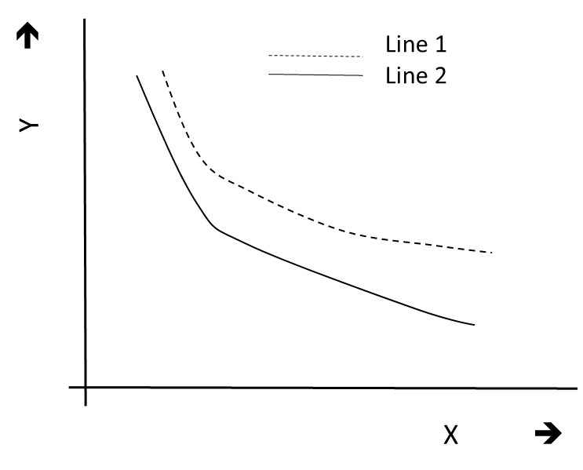
Table 1: Selected seminars related to industrial explosions
Event | Dates | Venue
13th International Symposium on Hazards, Prevention, and Mitigation of Industrial Explosions | 27-31 July | Braunschweig, Germany
11th International Symposium on Hazards, Prevention, and Mitigation of Industrial Explosions | 24-29 July | Dalian, China

Fig. 1. The dependence of Y on X for stages 1 and 2
Please provide 3-6 keywords immediately after the main part of the abstract, avoiding general and plural terms and multiple concepts (avoid, for example, 'and', 'of', etc.).
Keywords: hazards, prevention, mitigation, industrial explosions
References
Boilard, S.P., Amyotte, P.R., Khan, F.I., Dastidar, A.G. & Eckhoff, R.K. (2013). Explosibility of micron- and nano-size titanium powders. Journal of Loss Prevention in the Process Industries, 26(6): 1646-1654.
Eckhoff, R.K. (2003). Dust explosions in the process industries. Third edition. Gulf Professional Publishing, Amsterdam.

